Frank Sharpe – l39222594

Project Dissertation
Predicting House Prices Using Mathematical and LLM Models

Figures
Figure 1 - (KEEP and Keep, 2025) - house building 4
Figure 2 - (KEEP and Keep, 2025) - house price index 4
Figure 3 - (Kavlakoglu, 2021) - decision tree example 6
Figure 4 (Yao, 2024) - linear regression example 7
Figure 5 - (Abdul-Rahman et al., 2021) - actual price against predicted 8
Figure 6 - (Data.gov.uk, 2025) - landregistry 9

Table of Contents

Figures 1
Table of Contents 2
Abstract 3
Introduction 4
Literature Review 6
Data and Methodology 10
Results 11
Discussion 12
Ethics and Limitations 13
Conclusion 14
Appendices 15
References 16
Bibliography 18

Abstract
My aim for this project was to create a simple predictive model, it examined UK house prices by analysing past data . Then compared against other methods and LLM models and compare against a mathematical model.
The method used was linear regression and random forest to create house price predictions, this was used as it can predict the value based on many variables such as bedrooms and square footage (IBM, 2021).

Introduction
As of August 2025, the index is at 104.6 and the average property price in the UK is £272,995. The cost of real estate has increased by 3.0% over the last year and by 0.8% over the preceding month (Data.gov.uk, 2025). These two graphs below show how houses being built have slowed down, this in hand has caused house prices to rise.
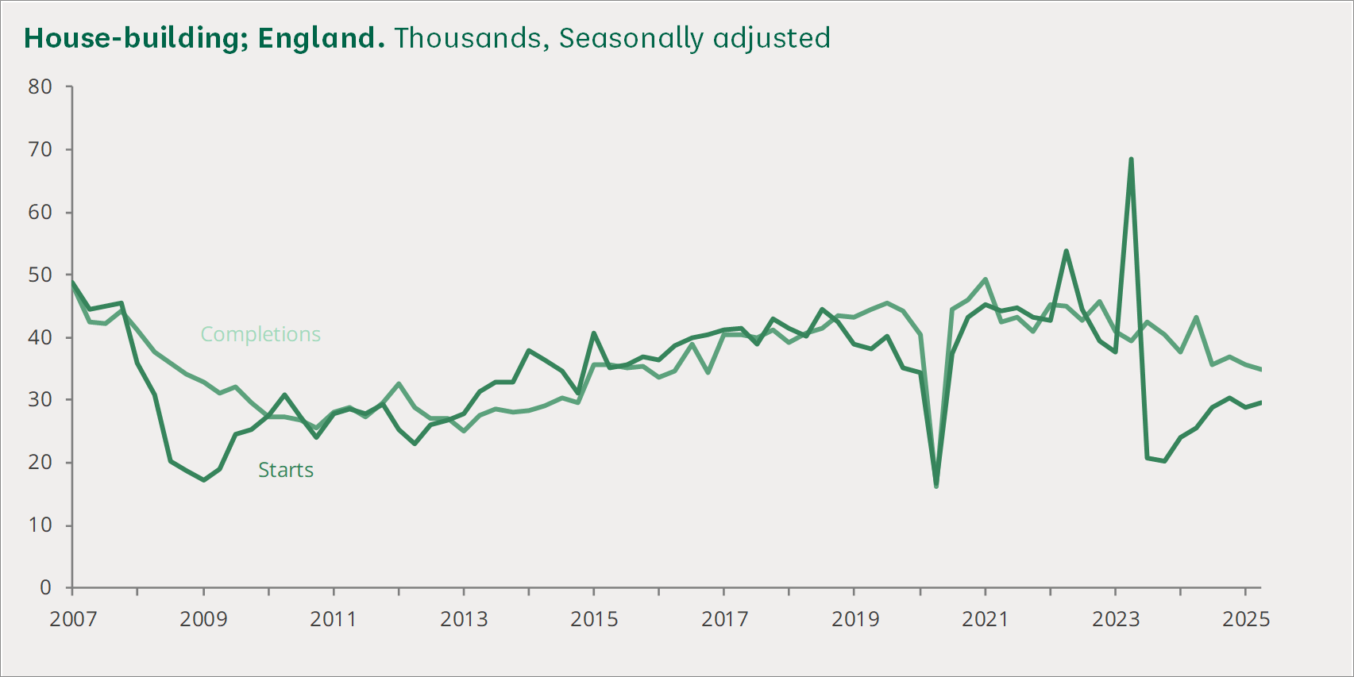
Figure 1 - (KEEP and Keep, 2025) - house building
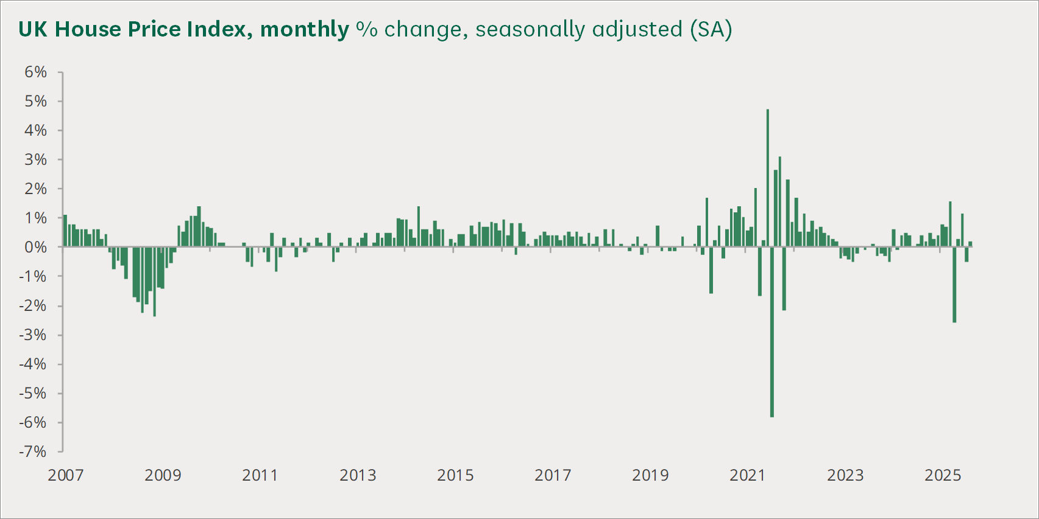
Figure 2 - (KEEP and Keep, 2025) - house price index

House price models are vital to provide data driven insights into the market, it can drive transparency for various stakeholders and increased efficiency and accuracy (Sharma, Harsora and Ogunleye, 2024). The traditional method of valuation for houses was comparing to recently sold prices, the cost of build the property or residual method which compares land prices this is used for development projects (FRICS, 2020). These traditional method can be useful for picking out the features and finding underlying problems such as loft conversion, as for valuation tools extra square footage usually isn’t added (YallaValue, 2025). However the time consuming process can take weeks or days also requiring an employee to visit the property meaning businesses hiring a employee just for valuation purposes (Nieberg, 2016).
The aim of this project is to compare the different ways of valuating properties comparing the different approaches to valuate prices. My aim is to find out how accurate valuation tools are and the effect it can have on the housing market and people looking to enter, it also aims to analysis the ethical problems that can caused by these tools.

Literature Review
House price prediction models use machine learning to help improve the accuracy they focus on location , square footage and number of rooms, an example of machine learning model that can be used is random forest, it combines the prediction of multiple decision tree to create a prediction (Truong et al., 2020).

Random forest
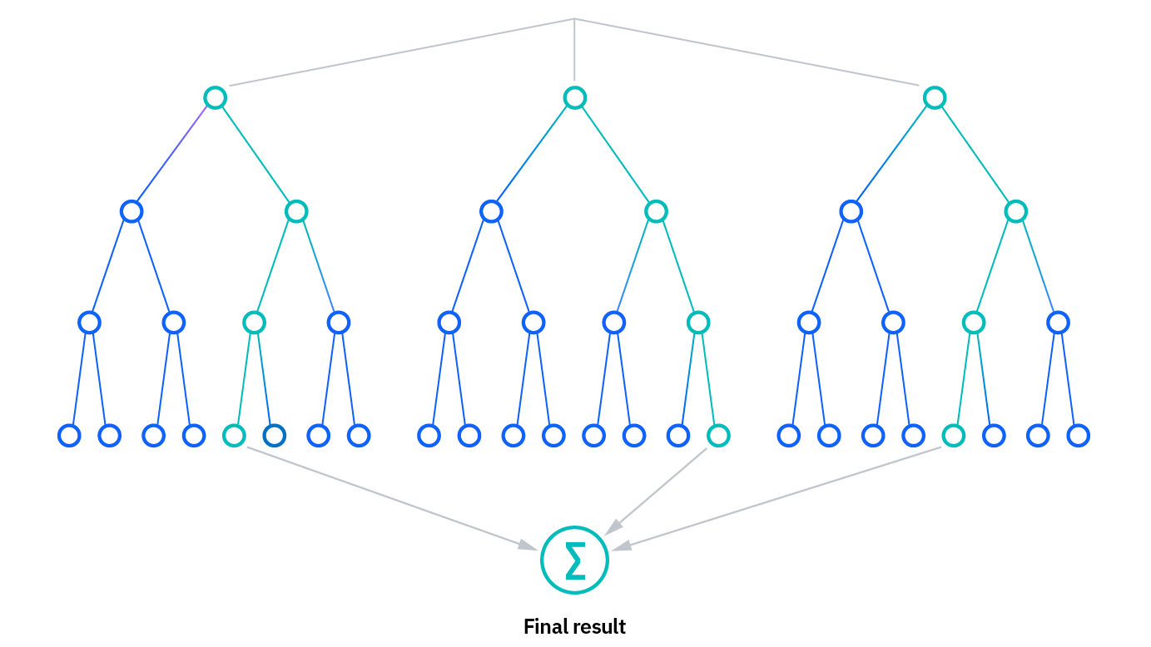
Figure 3 - (Kavlakoglu, 2021) - decision tree example
The benefits of using this method is the reduce risk of overfitting , it will lower the variance and prediction error. It is made to handle regression tasks with a high degree of accuracy so perfect for predicting house prices, however the accuracy depends on the size of the data set which can become time consuming, it can require more resources to process that data and the overall complexity (Kavlakoglu, 2021).

Linear regression
Another method many other papers use is linear regression it is supervised learning based machine learning algorithm. It carries out a regression job. Regression uses independent variables to model a goal prediction value. It is mostly utilised for predicting and determining the link between variables (Maloku, 2024).
An example of running linear regression is ;
from sklearn.linear_model import LinearRegression
regressor = LinearRegression()
regressor.fit(X_train, y_train)
(Yao, 2024)
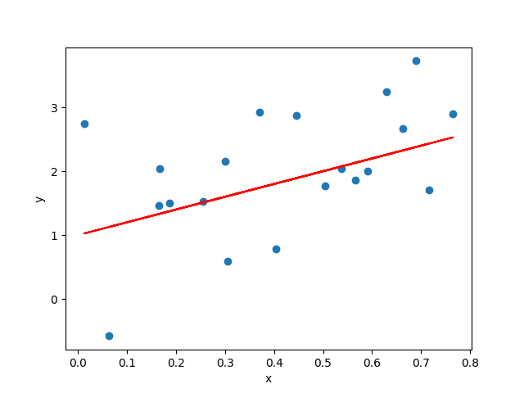
Figure 4 (Yao, 2024) - linear regression example
The simplicity to implement and interpret the outcomes makes it efficient, however outliers can have a huge impact on results , linear regression also assumes a linear relationship between dependent and independent variables (GeeksforGeeks, 2020).

Other studies to compare against
An example of a study to review is “Advanced Machine Learning Algorithms for House Price Prediction: Case Study in Kuala Lumpur”, this study focuses on a Malaysia housing dataset from Kaggle with around 21,995 rows of data. It provided locations, number of bedrooms , bathrooms, car parks , size , furnishing status , property type and distance to shop , school , hospital and stations(Abdul-Rahman et al., 2021).

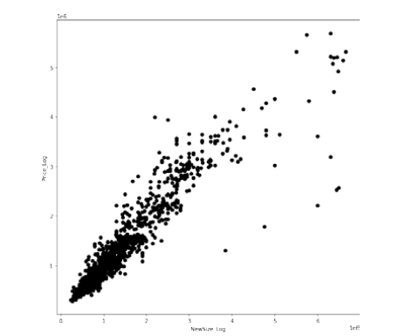
Figure 5 - (Abdul-Rahman et al., 2021) - actual price against predicted
The models the study compared was multiple linear regression , ridge regression and light GBM, they evaluated the mean absolute error, root mean square error and adjusted r squared(Abdul-Rahman et al., 2021). Result of the tests was XGBoost performed best MAE = 0.148, RMSE = 0.197, adjusted R² = 0.911. The conclusion for the oerall report was that the model was effective for Kuala Lumpur, but however for future work should include more attributes and expand beyond KL.
This study is focused on modern ML methods which help the accuracy, the paper has a clear structure and uses two different data sets, google maps was also used to help expand the attributes rather than basic features. However, the main disadvantage of this study is that it uses a simple train and test split, this can cause learning patterns from future data sets without the author realising. The geographical concern of the report being limited to Kuala lumpur, so the results don’t really show how well the model would work in other regions with different market behaviour. It is hard to understand the reliability as the authors don’t include any uncertainty estimates or interoperability, it is hard to understand why the model makes certain decisions (Abdul-Rahman et al., 2021).

Takeaway
Many studies use data sets from other countries but the focus of this report is on the UK housing market, the data set will include many attributes to help with predictions, making the accuracy increase. I want to focus on a simple model that will focus on accuracy and transparency to address the ethical concern regarding prediction models.

Data and Methodology

Data sets
https://reshare.ukdataservice.ac.uk/854942
https://www.gov.uk/government/statistical-data-sets/uk-house-price-index-data-downloads-may-2025

overview
The data covers 79% of the full market sales in the Land Registry PPD. This new linked dataset details 5,732,838 transactions in England and Wales between 2011 and 2019, along with each property's total floor area and the number of habitable rooms (Chi et al., 2019).it will cover the whole of the Uk to help with complexity I will put a capacity of 40,000 rows which exeedes the other study complete for Kular lumpar. I will also combine the Uk house price index this is used to calculate the overall market trends, if I used one model for training a jump in house prices may be unexplainable but the index can show the market trends for that year aligned with price.

fields
The key fields used are;
numberrooms
tfarea
HPI_at_Sale
Standardized_Property_Type_House
Postcode_Area
price

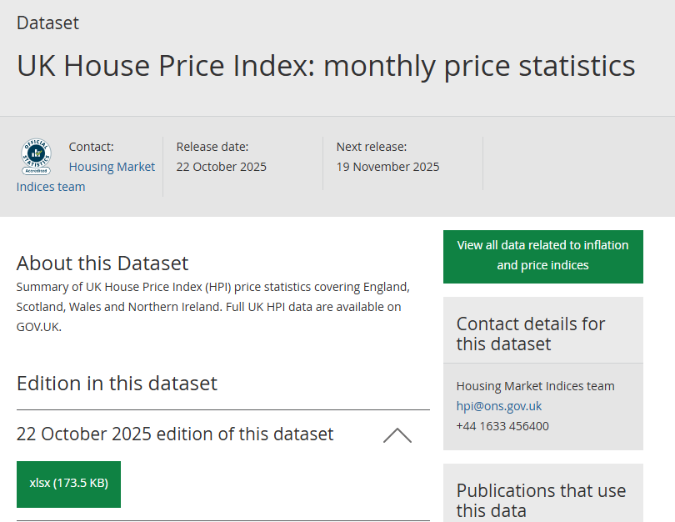
Figure 6 - (Ons.gov.uk, 2025) - Uk house price index
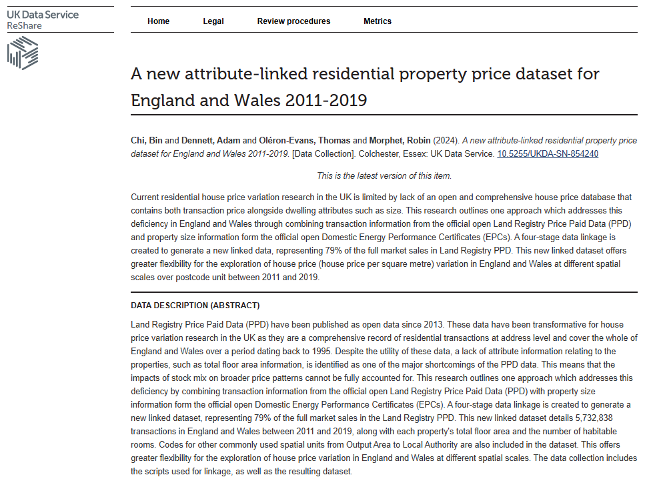
Figure 7 - prop.csv data - (Chi et al., 2019)

Clean data
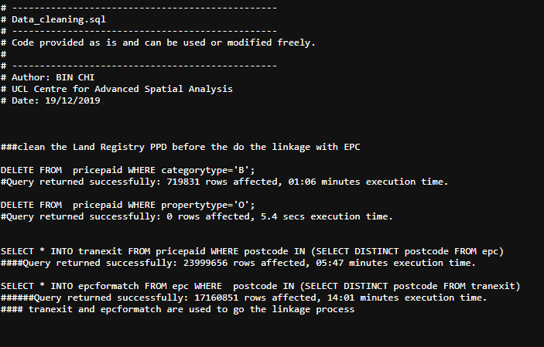
Figure 8 - data cleaning sql used by the dataset - (Chi et al., 2019)
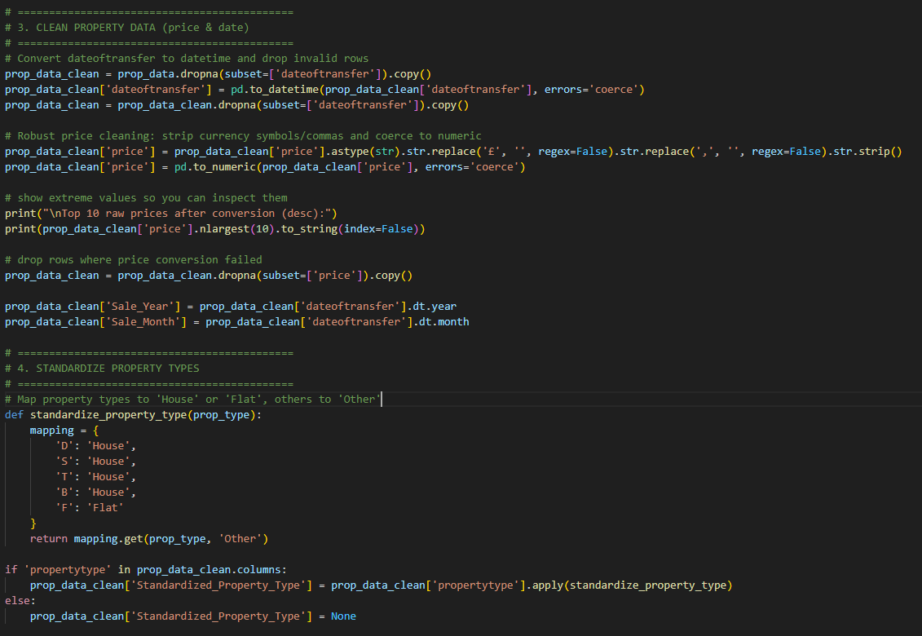
Figure 9 - clean property data
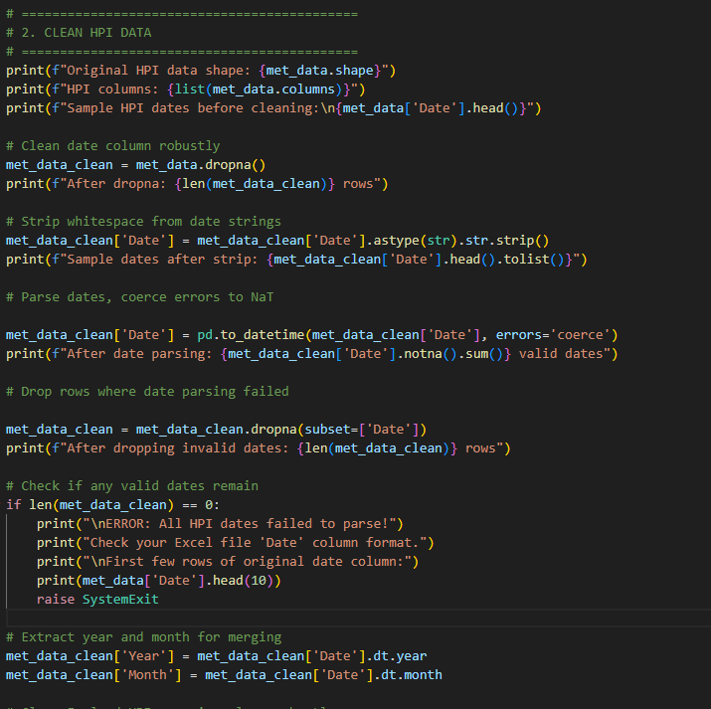
Figure 10 - clean hpi data
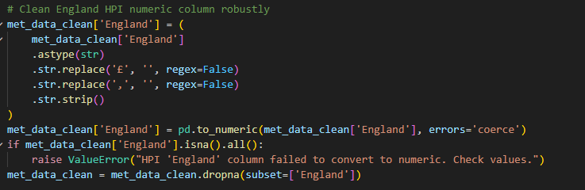
Figure 11 - clean hpi data

Methods

Mathematical model 1: Linear regression
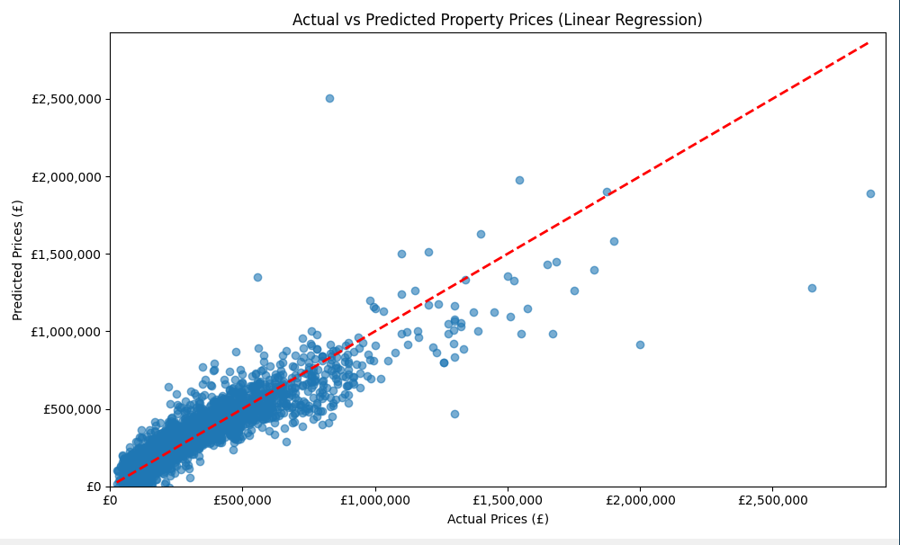
Figure 12 - linear regression model graph

Model 2 : random forest
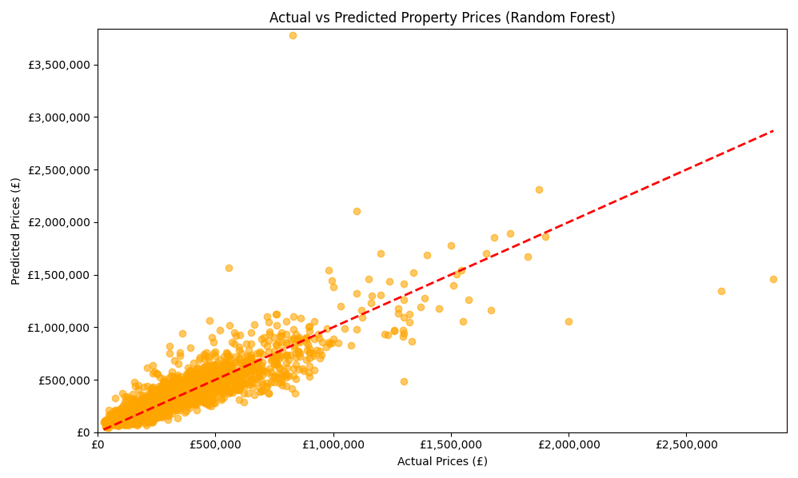
Figure 13 – Random forest graph model

Evaluation

Train test split

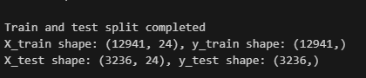
Figure 14 - data for train test split 80% training , 20% testing

Results
 | Model | RMSE | MAE | R2 score
0 | Linear regression | 106932.065752 | 68993.456168 | 0.790915
1 | Decision tree regressor | 168686.335006 | 87472.485682 | 0.479686
2 | Random forest regressor | 117391.019505 | 65304.513522 | 0.748014

Top 10 featured coefficients
Feature – Postcode area | Coefficient
Gu | 438466.888193
S1 | -313113.701422
S8 | -278387.204687
TS | -266152.272759
S7 | -259733.219593
S6 | -258117.752745
S2 | -253352.681120
TF | -236888.121203
NG | -223611.222721
S3 | -219966.960445

Size of dataset
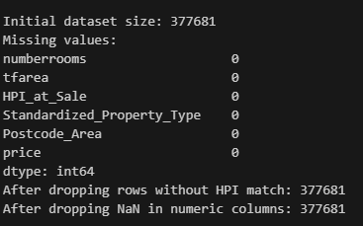
Figure 15 - size of dataset used

Discussion
RMSE ( root mean squared error) measures that average magnitude of the errors. The mean absolute error (MAE) it measures the average of the errors without considering direction , it is robust to outliers. R^2 score is a representation of the variance between prediction and real , a 0 means that you could predict that result yourself and a 1 shows a prefect prediction.
The results show that linear regression is the most accurate at predicting prices as shown my the R2 score being at 8 which is the closest to 1, decision tree shows a very inaccurate result being nearly 0.6 away from 1. Going through the RMSE and MAE results show that random forest regression has a lowest MAE meaning that its avg prediction error is the smallest
Coefficients indicate predicted value such as a positive coefficient can mean that postcode is associated with a higher predicted value;
Results such as Guildford region with a coefficient of £438,466.89 shows that having this postcode will increase predicted value by over £438k compared to baseline category, the largest negative postcode was Sheffield having a - £313,113.70 coefficient causing values to be predicted less in that area compared to the baseline. These can be effected by real world thing such as GU being a London commuter belt and has high property prices compared to S1 postcode which covers more affordable properties and lower prices compared to London regions.
This large gap shows the substantial regional difference with property values across the UK, the model has identified that location is the largest predator in the features that were used.

Ethics and Limitations
main limitations of the dataset is that the data is 5 years old that lowers the prediction accuracy for any house up for sale after those dates, another main limitation is the technology as was not able to handle the whole dataset as it contained over 5 million sales.
An ethical problem contains the dataset containing peoples house data such as their address and rooms this could cause some people to be unhappy with their house inside the dataset and being used for predicting, as this data is containing past sales data may not be current and could be incorrect, it also does not take into account any renovations or extra features that a human would see as valuable.
The dataset was so large that bias should have been mitigated by the large and different amount of areas , this was shown by the prices being accurate to areas and showing London areas with larger prices compared to up north where the prices were less.
Another ethical risk involves the risk of algorithmic pricing this is involved when algorithms will collude with other algorithms to raise or lower prices as determined by companies for financial gain and benefit (Spann et al., 2025).
As the model is for academic purposes only it doesn’t need to consider as many ethical laws as the data is on the internet so it okay for fair use such as this project.

Conclusion
Include:
- Restate aim and what was achieved
- Which model performed best
- Main takeaway (e.g., simple models can predict trends reasonably well)
- Brief comment on future improvements
The aim of the project was Predicting House Prices Using Mathematical and LLM Models, the project was completed successfully and went through 3 ways of completing it, the most accurate model being linear regression, this could be due to the simplicity and efficient way of predicting (Yadav, 2024).
Future ways improve the project involves increasing the size of the dataset with brand new data which is up to data, this will increase the accuracy and could involve predicting future trends into the future. This will be used to help with real estate and personal sellers know when is best to buy or sell their house (Zhang, 2025).
Another future adaptation would be to develop an app that users could input their data into and get a predicted house price back this would help people be able to get a quicker and more efficient way of selling their home (Brown, 2025).

Appendices
- Python code screenshots or GitHub link
- Extra graphs or tables
- Data cleaning steps

Coding editions

First edition just graph of results from excel file
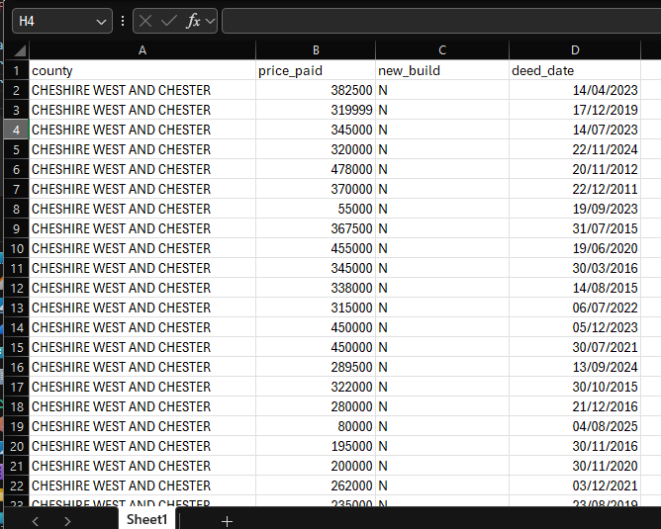
Figure 16 - 500.xlsx - house price sale list
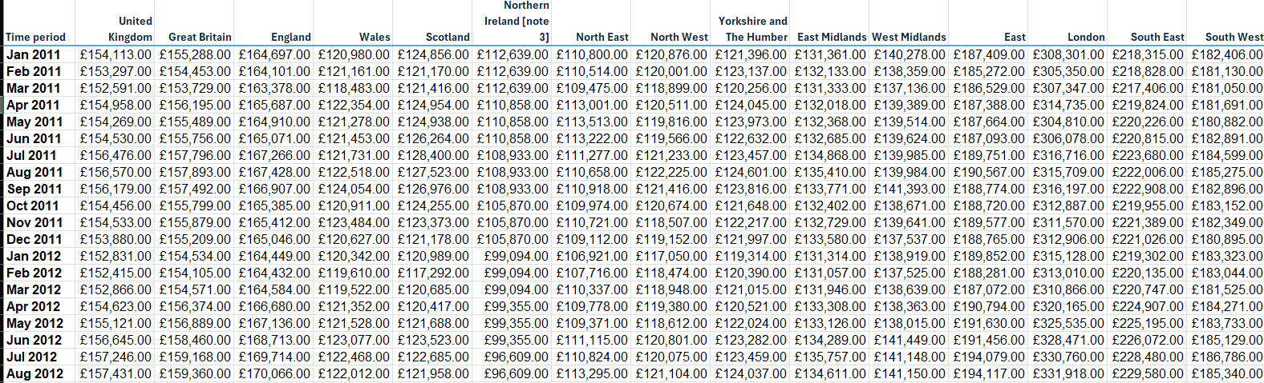
Figure 17 - met.xlsx - property stat avg
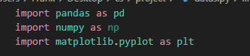
Figure 18 - libarys used
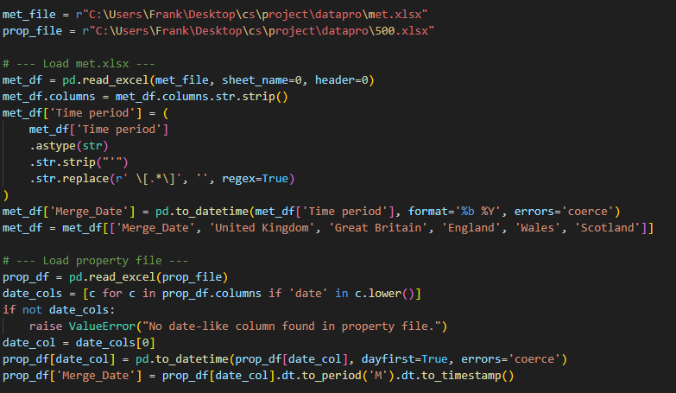
Figure 19 - load both files merge deed date and time perdod
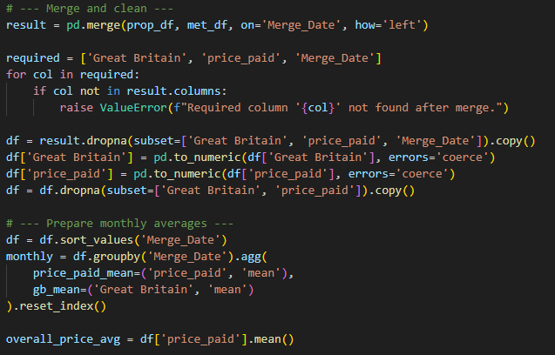
Figure 20 - sort the data and create means for the data such as price paid and great Britain average
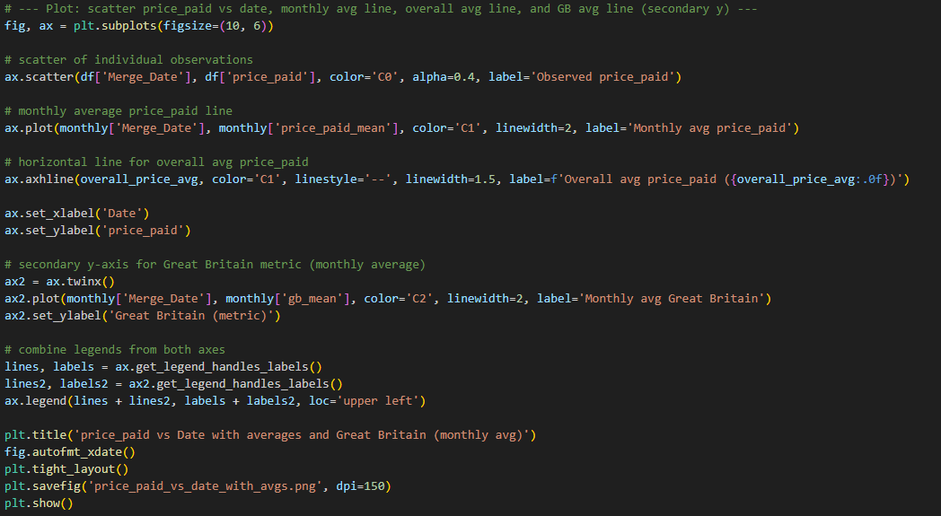
Figure 21 - plot the data using the data as axis
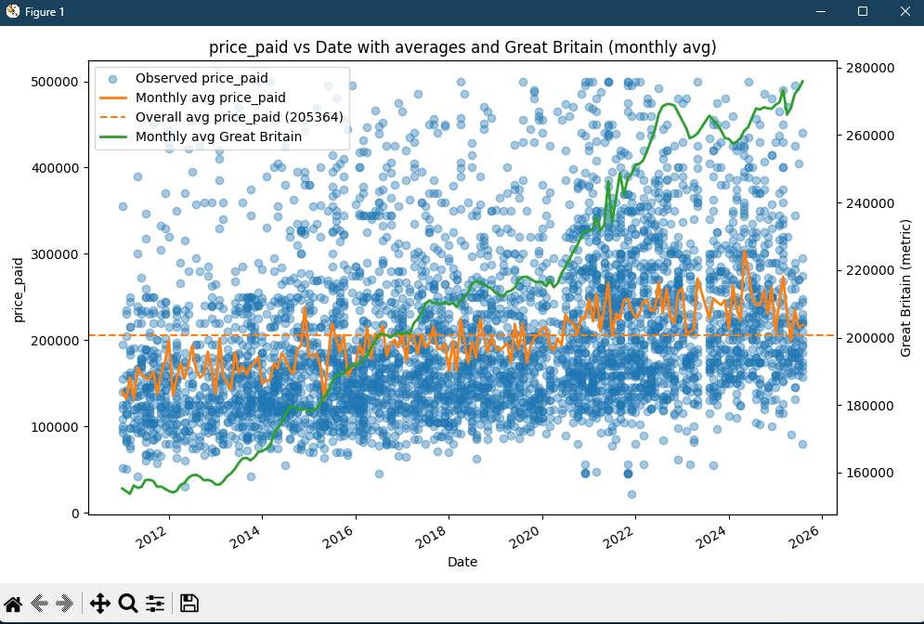
Figure 22 - graph to show the results

2nd edition
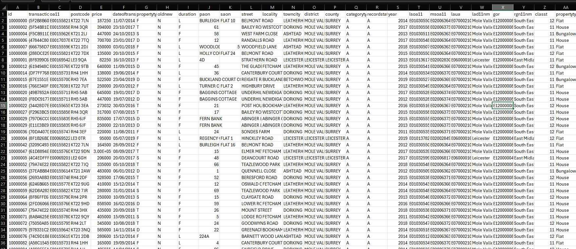
Figure 23 - prop.csv - list of property data
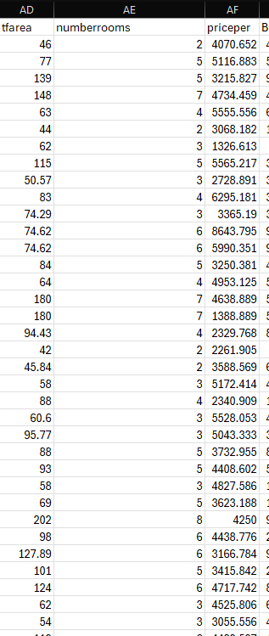
Figure 24 - prop.csv - number of rooms and size
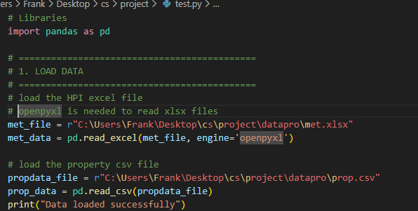
Figure 25 - load the excel files
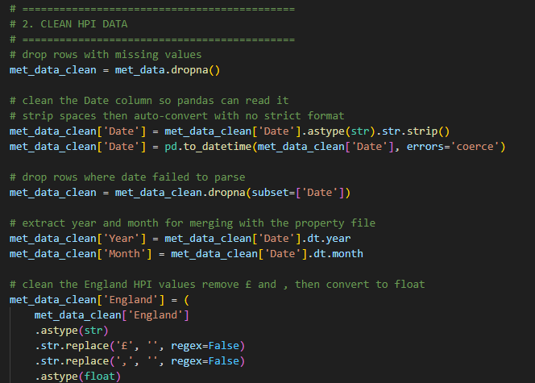
Figure 26 - clean the data removing £ signs and empty rows
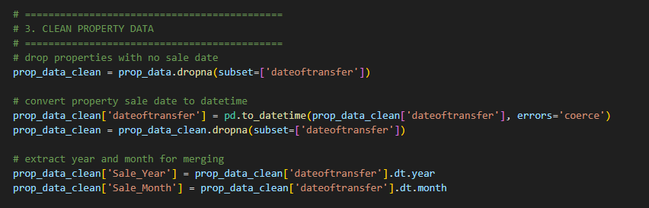
Figure 27 - clean prop.csv data
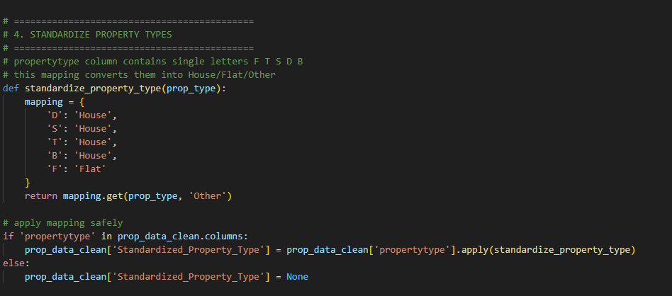
Figure 28 - put property types into categories
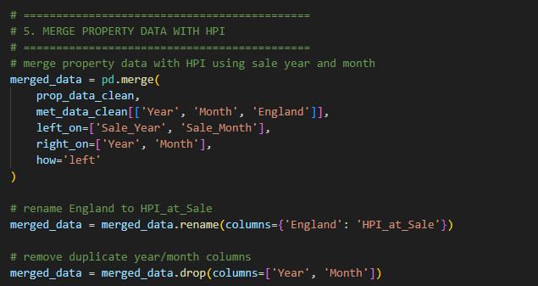
Figure 29 - combine the dates for hpi and sale date
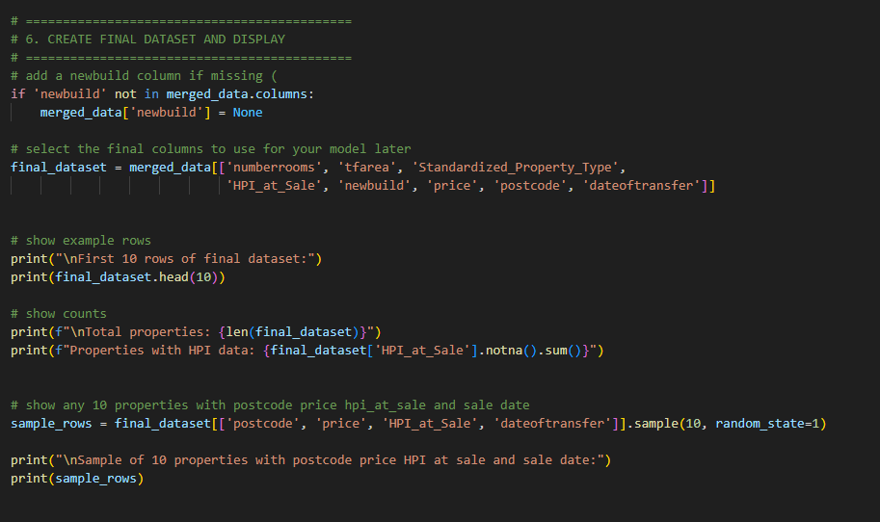
Figure 30 - display property sale date and price against hpi at sale
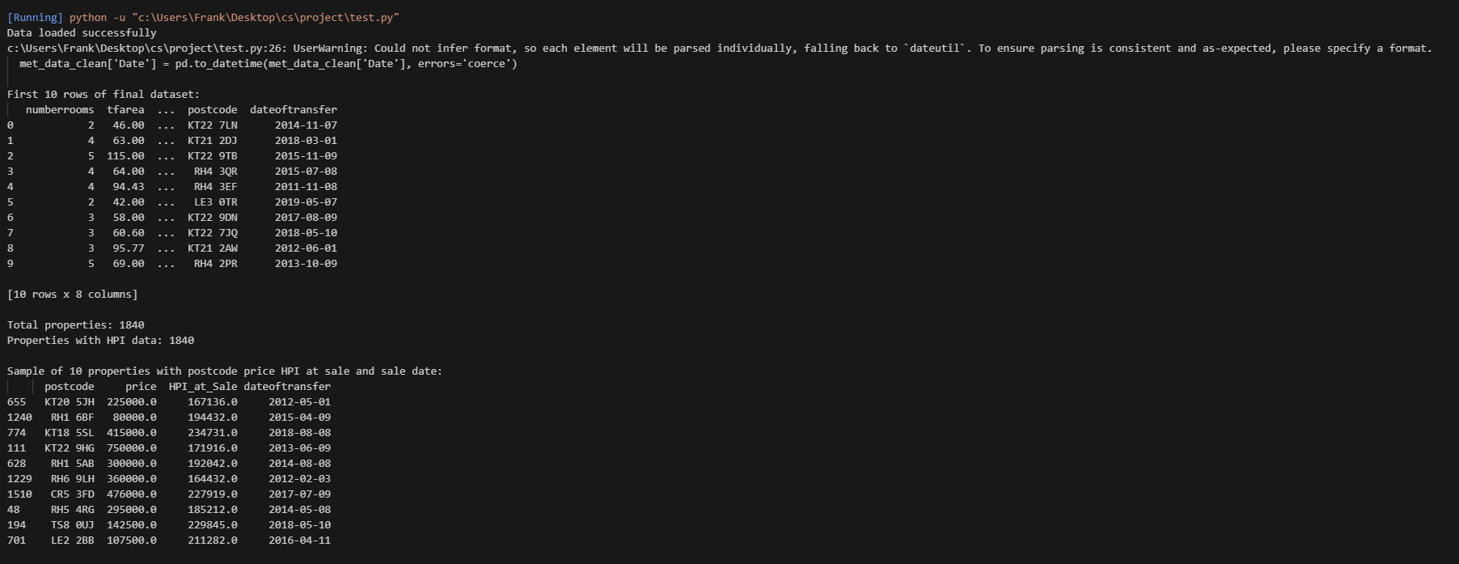
Figure 31 - results of first 10 rows

3rd edition
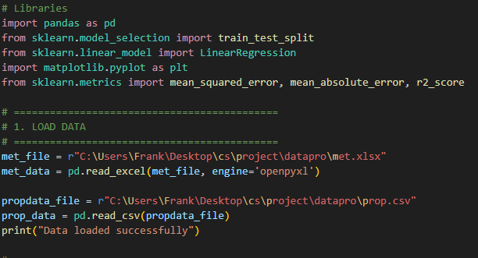
Figure 32 - library needed
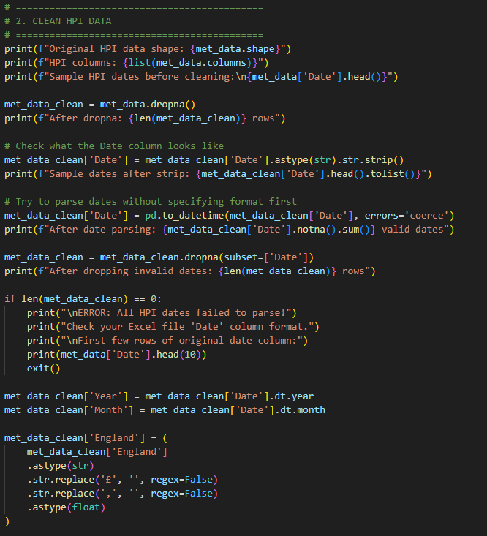
Figure 33 - clean the data from hpi
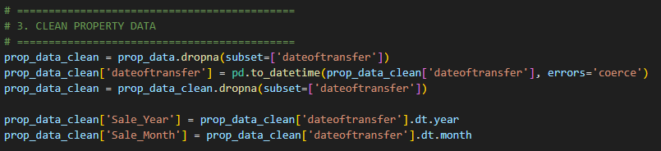
Figure 34 - clean property data
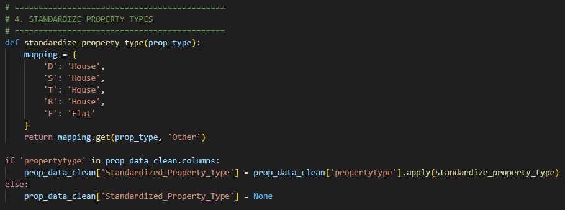
Figure 35 - put property types into catorgories
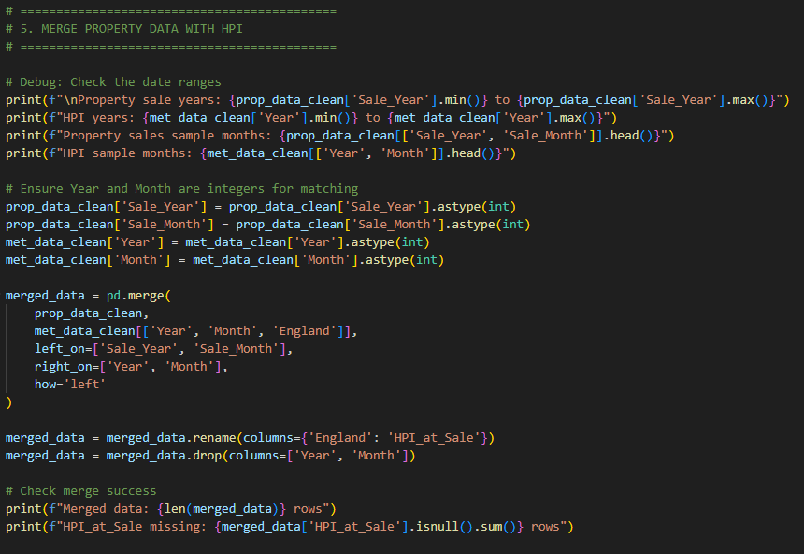
Figure 36 - merge sale date against hpi at sale
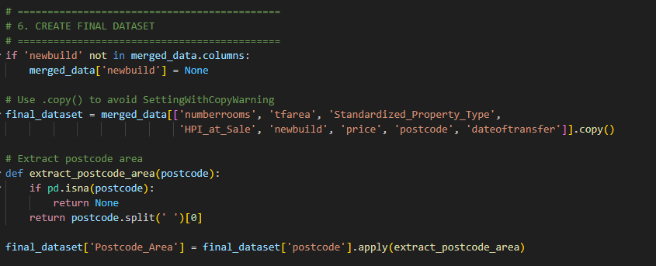
Figure 37 - create a final dataset to use for training
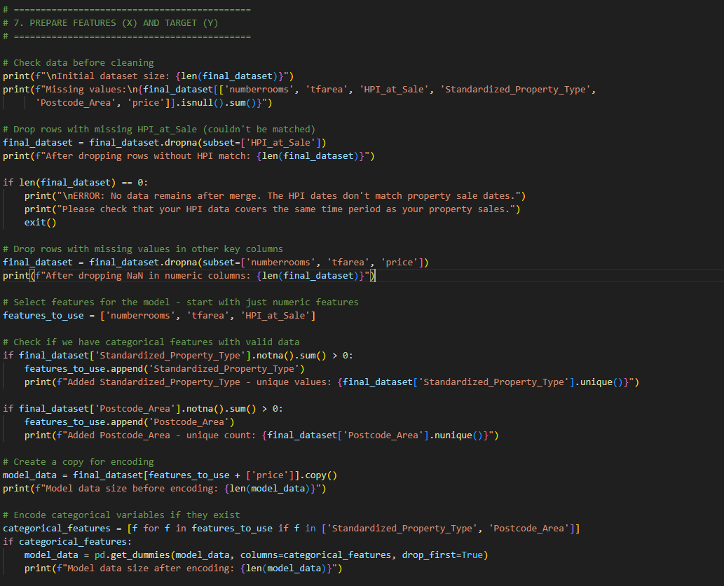
Figure 38 - get the features needed to train x and y
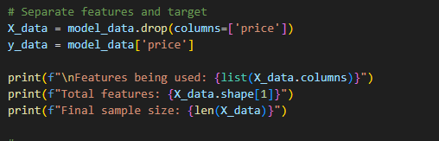
Figure 39 - features being used
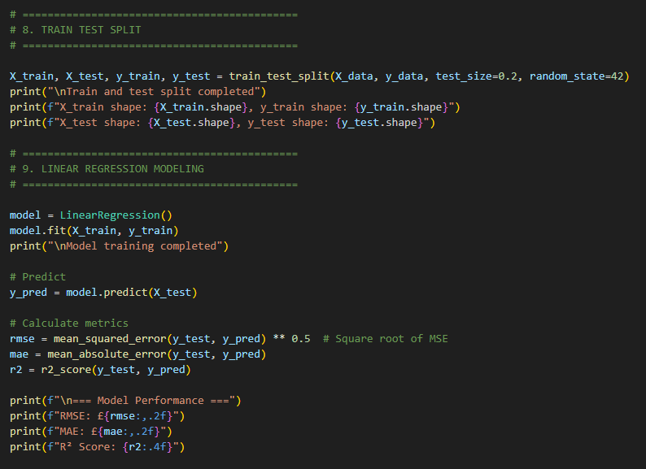
Figure 40 - train test split of 20/80 and linear regression implementation

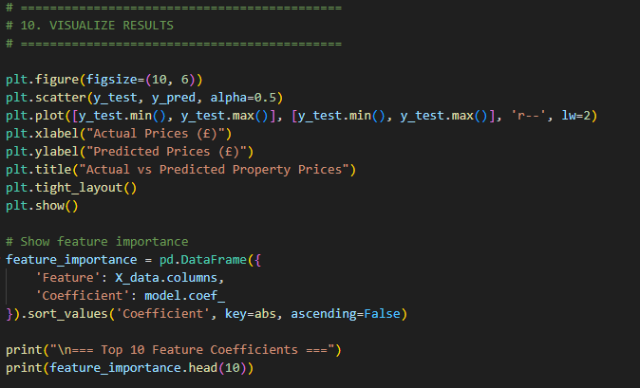
Figure 41 - visualise the linear regression

4th edition
Figure 42 - decision tree model libary
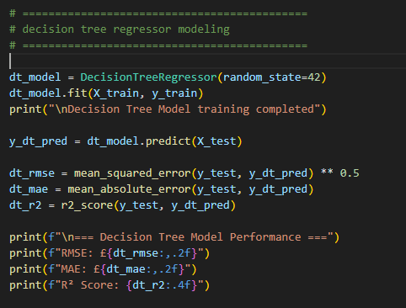
Figure 43 - decision tree used to test the data
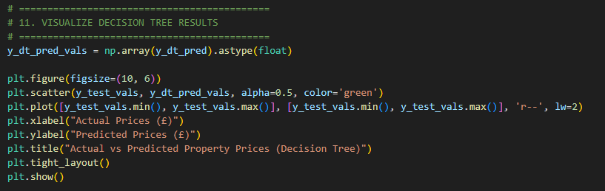
Figure 44 - visualise the data
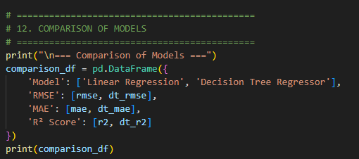
Figure 45 - comparisons of the models

Graphs with 2000 rows of data
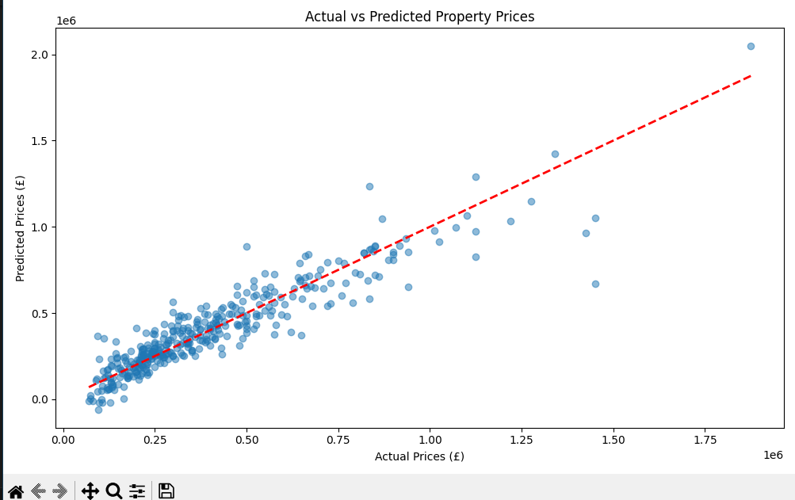
Figure 46 - linear regression graph
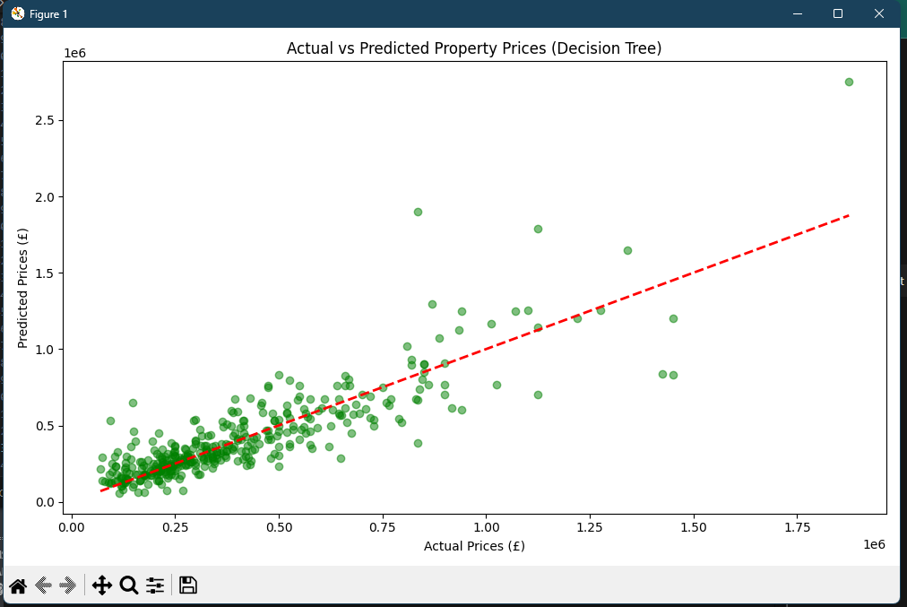
Figure 47 - decision tree graph

=== Top 10 Feature Coefficients ===
Feature Coefficient
25 Postcode_Area_TS4 -394942.205150
26 Postcode_Area_TS5 -309790.392464
23 Postcode_Area_TS1 -274600.436037
11 Postcode_Area_LE2 -227224.030656
12 Postcode_Area_LE3 -225727.921343
13 Postcode_Area_LE4 -209646.727763
14 Postcode_Area_LE5 -188378.671886
27 Postcode_Area_TS7 -187602.430453
24 Postcode_Area_TS3 -174763.752928
28 Postcode_Area_TS8 -124128.830915

=== Comparison of Models ===
Model RMSE MAE R� Score
0 Linear Regression 105663.442940 73394.814451 0.847304
1 Decision Tree Regressor 153050.295516 97875.714674 0.679635

Graphs with 10,000 rows of data

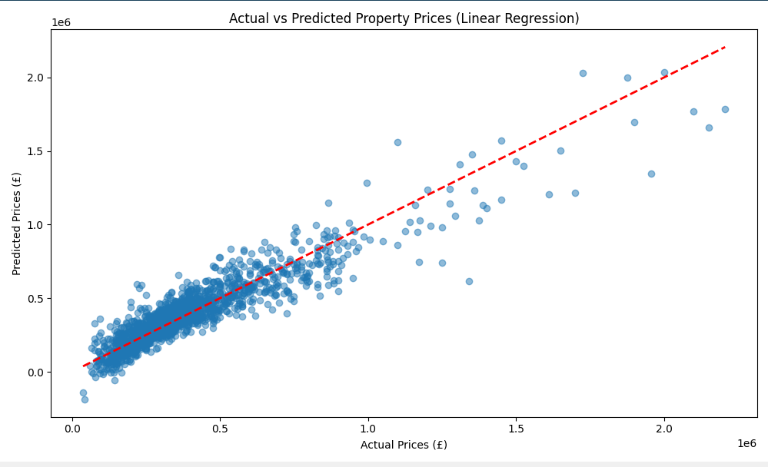
Figure 48 - linear regression model

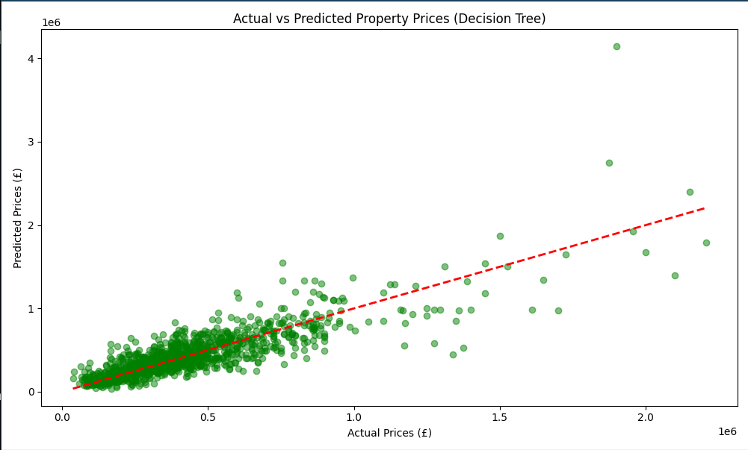
Figure 49 - decision tree model

=== Top 10 Feature Coefficients ===
Feature Coefficient
25 Postcode_Area_TS4 -394942.205150
26 Postcode_Area_TS5 -309790.392464
23 Postcode_Area_TS1 -274600.436037
11 Postcode_Area_LE2 -227224.030656
12 Postcode_Area_LE3 -225727.921343
13 Postcode_Area_LE4 -209646.727763
14 Postcode_Area_LE5 -188378.671886
27 Postcode_Area_TS7 -187602.430453
24 Postcode_Area_TS3 -174763.752928
28 Postcode_Area_TS8 -124128.830915

Metric | Linear regression | Decision Tree Model | Interpretation
RMSE (Root Mean Squared Error) | £99,899.70 | £146,042.94 | The average magnitude of the prediction errors. Lower is better.
MAE (Mean Absolute Error) | £71,659.06 | £88,324.62 | The average absolute difference between predicted and actual prices. Lower is better.
$R^2$ Score ($R^2$) | 0.8522 | 0.6840 | The proportion of the variance in house prices explained by the model. Closer to 1.0 is better.

graphs with 20,000 rows of data
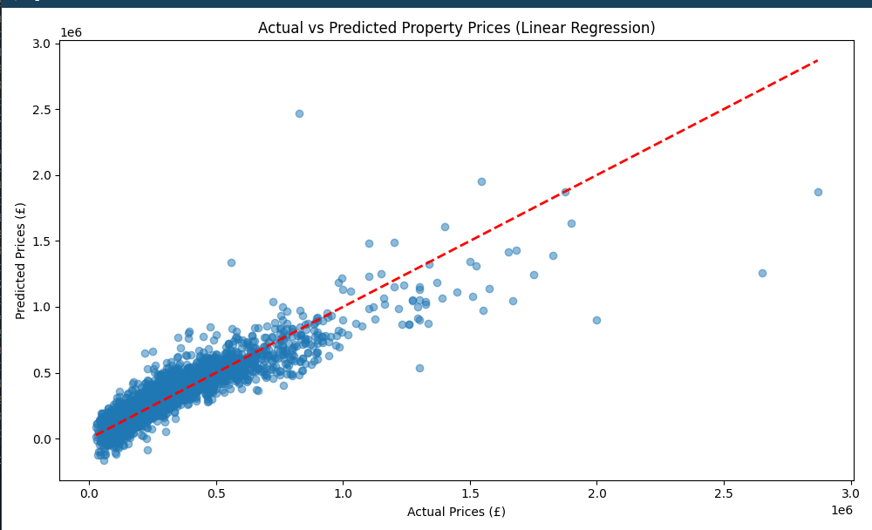
Figure 50 - linear regression graph
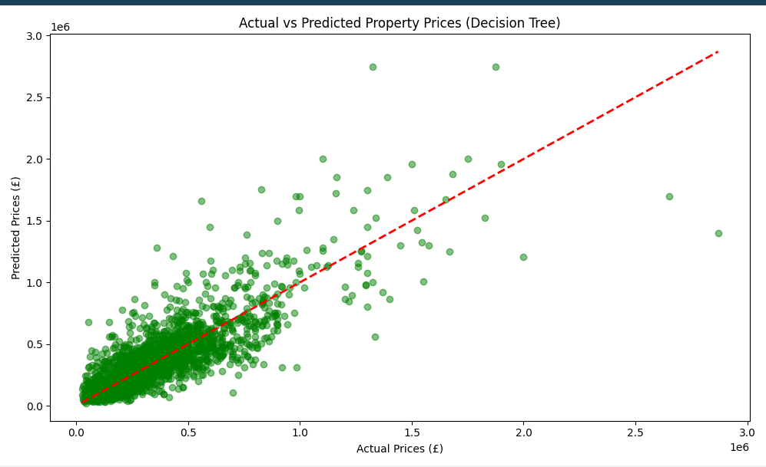
Figure 51 - decision tree graph

=== Top 10 Feature Coefficients ===
Feature Coefficient
5 Postcode_Area_KT13 548139.347921
4 Postcode_Area_GU25 443143.705919
67 Postcode_Area_TS1 -396347.675423
56 Postcode_Area_SM2 361004.208824
71 Postcode_Area_TS13 -322948.615527
42 Postcode_Area_S13 -315152.705354
72 Postcode_Area_TS14 -301936.513461
86 Postcode_Area_WA13 -297111.869914
49 Postcode_Area_S63 -287478.449794
54 Postcode_Area_S80 -286214.317271

=== Comparison of Models ===
Model RMSE MAE R� Score
0 Linear Regression 104029.960354 67267.240898 0.802110
1 Decision Tree Regressor 139277.126947 85053.389370 0.645296

Random forest
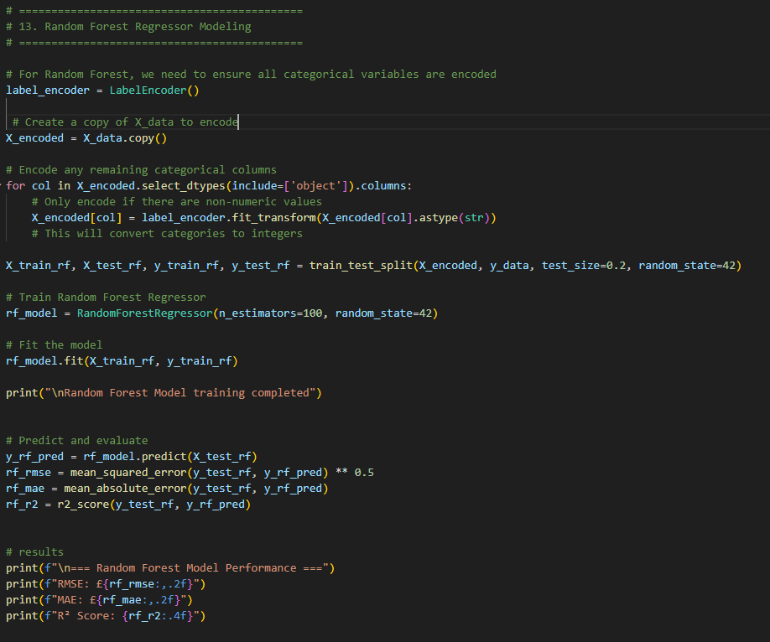
Figure 52 - random forest
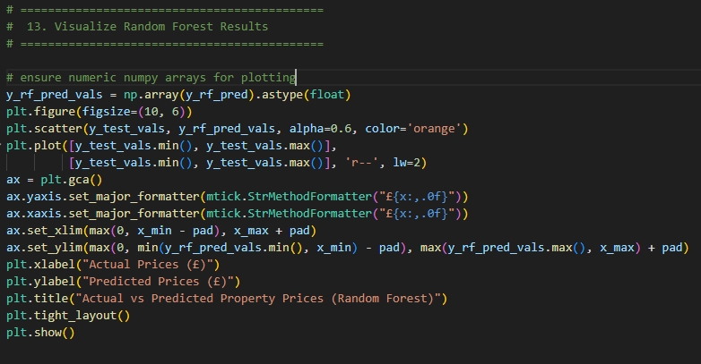
Figure 53 - random forest graph code

References
IBM (2021). Linear Regression. [online] Ibm.com. Available at: https://www.ibm.com/think/topics/linear-regression [Accessed 13 Nov. 2025].
‌ Sharma, H., Harsora, H. and Ogunleye, B. (2024). An Optimal House Price Prediction Algorithm: XGBoost. Analytics, [online] 3(1), pp.30–45. doi:https://doi.org/10.3390/analytics3010003.
‌ Data.gov.uk. (2025). UK House Price Index. [online] Available at: https://landregistry.data.gov.uk/app/ukhpi/ [Accessed 13 Nov. 2025].
‌Yao, E. (2024). Predict Housing Price using Linear Regression in Python | Towards Data Science. [online] Towards Data Science. Available at: https://towardsdatascience.com/predict-housing-price-using-linear-regression-in-python-bfc0fcfff640/ [Accessed 14 Nov. 2025].
‌Chi, B., Dennett, A., Oléron-Evans, T. and Morphet, R. (2019). A new attribute-linked residential property price dataset for England and Wales 2011-2019 - ReShare. Ukdataservice.ac.uk. [online] doi:https://reshare.ukdataservice.ac.uk/854942/1/tranall2011_19.csv.
‌ Spann, M., Bertini, M., Koenigsberg, O., Zeithammer, R., Aparicio, D., Chen, Y., Fantini, F., Jin, G.Z., Morwitz, V.G., Popkowski Leszczyc, P., Vitorino, M.A., Williams, G.Y. and Yoo, H. (2025). Algorithmic pricing: Implications for marketing strategy and regulation. International Journal of Research in Marketing. [online] doi:https://doi.org/10.1016/j.ijresmar.2025.05.001.
‌ Yadav, A. (2024). Linear Regression for Stock Market Prediction. [online] Medium. Available at: https://medium.com/@amit25173/linear-regression-for-stock-market-prediction-6039f1ea5c1b [Accessed 21 Nov. 2025].
‌ Zhang, H. (2025). Residential real estate price prediction based on adaptive loss function and feature embedding optimization. Humanities and Social Sciences Communications, [online] 12(1). doi:https://doi.org/10.1057/s41599-025-05217-9.
‌ Brown, P. (2025). The transformative potential of AI in real estate. [online] Lewissilkin.com. Available at: https://www.lewissilkin.com/insights/2025/02/26/the-transformative-potential-of-ai-in-real-estate [Accessed 21 Nov. 2025].
‌

Abdul-Rahman, S., Zulkifley, N.H., Ibrahim, I. and Mutalib, S. (2021). Advanced Machine Learning Algorithms for House Price Prediction: Case Study in Kuala Lumpur. International Journal of Advanced Computer Science and Applications, 12(12). doi:https://doi.org/10.14569/ijacsa.2021.0121291.
‌

KEEP, M. and Keep, M. (2025). Housing market: Economic indicators. [online] House of Commons Library. Available at: https://commonslibrary.parliament.uk/research-briefings/sn02820/ [Accessed 13 Nov. 2025].
‌ FRICS, J.L. (2020). APC: the five valuation methods. [online] Rics.org. Available at: https://ww3.rics.org/uk/en/journals/property-journal/apc-5-valuation-methods.html [Accessed 13 Nov. 2025].
‌
YallaValue. (2025). Comparing Instant and Traditional Property Valuations. [online] Available at: https://yallavalue.com/blog/instant-property-valuations-vs-traditional-property-valuations-pros-and-cons [Accessed 13 Nov. 2025].
‌
Nieberg, D. (2016). The Pros and cons of using house price evaluation tools in the current market. [online] Property Rescue. Available at: https://propertyrescue.co.uk/useful-guides-articles/the-pros-and-cons-of-using-house-price-evaluation-tools-in-the-current-market/ [Accessed 13 Nov. 2025].
‌Truong, Q., Nguyen, M., Dang, H. and Mei, B. (2020). Housing Price Prediction via Improved Machine Learning Techniques. Procedia Computer Science, [online] 174, pp.433–442. doi:https://doi.org/10.1016/j.procs.2020.06.111.
‌
Maloku, F. (2024). House Price Prediction Using Machine Learning and Artificial Intelligence. Journal of Artificial Intelligence & Cloud Computing, [online] 3(4), pp.1–10. doi:https://doi.org/10.47363/jaicc/2024(3)357.
‌GeeksforGeeks (2020). ML Advantages and Disadvantages of Linear Regression. [online] GeeksforGeeks. Available at: https://www.geeksforgeeks.org/machine-learning/ml-advantages-and-disadvantages-of-linear-regression/ [Accessed 14 Nov. 2025].
‌

Bibliography

GeeksforGeeks (2018). Reading an excel file using Python. [online] GeeksforGeeks. Available at: https://www.geeksforgeeks.org/python/reading-excel-file-using-python/ [Accessed 15 Nov. 2025].

‌GeeksforGeeks (2019). Random Forest Regression in Python. [online] GeeksforGeeks. Available at: https://www.geeksforgeeks.org/machine-learning/random-forest-regression-in-python/ [Accessed 20 Nov. 2025].
‌Matplotlib.org. (2024). Matplotlib — Visualization with Python. [online] Available at: https://matplotlib.org/ [Accessed 20 Nov. 2025].
‌
Babitz, K. (2019). Introduction to Plotting with Matplotlib in Python. [online] Datacamp.com. Available at: https://www.datacamp.com/tutorial/matplotlib-tutorial-python [Accessed 20 Nov. 2025].
‌
Yildiz, D.M. (2025). Understanding the Differences and Similarities Between Feature Importance and Feature Coefficients. [online] Medium. Available at: https://medium.com/@muslumyildiz17/understanding-the-differences-and-similarities-between-feature-importance-and-feature-coefficients-08ab29bdb5b8 [Accessed 20 Nov. 2025].
‌

GeeksforGeeks (2021). How to Merge Multiple Excel Files into a Single Files with Python. [online] GeeksforGeeks. Available at: https://www.geeksforgeeks.org/python/how-to-merge-multiple-excel-files-into-a-single-files-with-python/ [Accessed 15 Nov. 2025].
‌
W3schools.com. (2025). W3Schools.com. [online] Available at: https://www.w3schools.com/python/matplotlib_pyplot.asp [Accessed 15 Nov. 2025].
‌
Mirko Stojiljković (2024). Linear Regression in Python. [online] Realpython.com. Available at: https://realpython.com/linear-regression-in-python/ [Accessed 16 Nov. 2025].
‌
Chi, B., Dennett, A., Oléron-Evans, T. and Morphet, R. (2019). A new attribute-linked residential property price dataset for England and Wales 2011-2019 - ReShare. Ukdataservice.ac.uk. [online] doi:https://reshare.ukdataservice.ac.uk/854942/1/tranall2011_19.csv.
‌
scikit-learn. (2025). train_test_split. [online] Available at: https://scikit-learn.org/stable/modules/generated/sklearn.model_selection.train_test_split.html [Accessed 19 Nov. 2025].
‌

Kavlakoglu, E. (2021). Decision trees. [online] Ibm.com. Available at: https://www.ibm.com/think/topics/decision-trees [Accessed 19 Nov. 2025].
‌
GeeksforGeeks (2018). Linear Regression in Machine learning. [online] GeeksforGeeks. Available at: https://www.geeksforgeeks.org/machine-learning/ml-linear-regression/ [Accessed 19 Nov. 2025].
‌

scikit-learn. (2025). 1.10. Decision Trees. [online] Available at: https://scikit-learn.org/stable/modules/tree.html [Accessed 19 Nov. 2025].
‌
Cbre.co.uk. (2024). Real estate firms should move faster on AI adoption, with new technology poised to transform sector. [online] Available at: https://www.cbre.co.uk/press-releases/real-estate-firms-should-move-faster-on-ai-adoption-with-new-technology-poised-to-transform-sector [Accessed 21 Nov. 2025].
‌
EXPO REAL. (2025). EXPO REAL. [online] Available at: https://exporeal.net/en/industry-topics/ai-real-estate/ [Accessed 21 Nov. 2025].
‌
Tyson, L. (2025). How AI in Real Estate Is Shaping a Smarter, More Efficient Market. [online] Medium. Available at: https://medium.com/@lenaztyson/how-ai-in-real-estate-is-shaping-a-smarter-more-efficient-market-348b6db90148 [Accessed 21 Nov. 2025].
‌
Perry, C. (2022). SimpleBar. [online] Altusgroup.com. Available at: https://www.altusgroup.com/insights/the-real-estate-ai-debate-risk-or-revolution/?utm_source=google&utm_medium=organic [Accessed 21 Nov. 2025].
‌
Cbre.co.uk. (2024). Artificial Intelligence and real estate market forecasting. [online] Available at: https://www.cbre.co.uk/insights/articles/artificial-intelligence-and-real-estate-market-forecasting [Accessed 21 Nov. 2025].
‌
Matterport. (2025). AI in Real Estate: How To Use Technology To Elevate Your Marketing. [online] Available at: https://matterport.com/en-gb/blog/ai-real-estate?srsltid=AfmBOooW1XeIIokkQJxULhf8MSSyf3pbJE6M-r26RuUCYf6a6k6rBAEL [Accessed 21 Nov. 2025].
‌
Placester: #1 Website Builder for Real Estate Agents, Teams and Brokers. (2025). How to use AI for real estate? 12 Winning strategies (2025). [online] Available at: https://placester.com/real-estate-marketing-academy/how-to-use-ai-in-real-estate [Accessed 21 Nov. 2025].
‌
Szumilo, N., & Wiegelmann, T. (2024). Real Estate Insights AI: real estate’s new roommate – the good, the bad and the algorithmic. Journal of Property Investment & Finance, 42(2), 211–217. https://doi.org/10.1108/JPIF-01-2024-0001
Zekri, M. (2025). Data-driven literature analysis of artificial intelligence (AI) in real estate research: a bibliometric and machine learning-based approach. Property Management, 1–25. https://doi.org/10.1108/PM-04-2025-0059

